Media’s Effect on Public Opinion : A SURVEY BASED ANALYSIS

Preeti Saini, Kanishk Chauhan, Nishtha Nanda, Madhav Sood, Sahil preeti.saini@chitkara.edu.in , Kanishk1739.be22@chitkara.edu.in , Madhav1864.be22@chitkara.edu.in, Nishtha1994.be22@chitkara.edu.in, Sahil2209.be22@chitkara.edu.in
Chitkara University Institute of Engineering and Technology Chitkara University, Punjab, India

ABSTRACT

The media has a pivotal role in the formation of public opinion by affecting people's perceptions of issues, their understanding of events, and the evidence they used to inform their attitudes. This review integrates research over the past 50 years to explore how media influence processes of opinion formation through traditional and digital channels. Agenda- setting, framing theory, the social amplification of risk, and uses and gratifications theory are examined to emphasise the role of media in setting the public agenda, shaping interpretative frames, and in interaction with motives of media users. Evidence shows the media plays an important role in shaping political ideology, risk and environmental attitudes, and perceptions of public health, with effects differentiating between areas of concern and different types of audiences. The advent of digital media has amplified and complicated these processes through "algorithmic constitution", "filter bubbles", mis- and disinformation, and computational propaganda, with implications for democratic decision making and trust in institutions. But individual-level factors - ideological and political attitudes, political knowledge, media literacy, and information processing biases - shape the magnitude and direction of media's influence. Although the media do not unilaterally shape people's opinions, it strongly affects opinion topics and the way people process complex issues. The results highlight the importance of improved media accountability, improved media literacy education and improved platform management, to maintain informed public debate. Essentially, the changing dynamics of media influence on public opinion formation remains critical to preserving democratic societies in an increasingly digital and polarised media environment.
Keywords: media effects, public opinion, agenda-setting, media literacy, digital media and communication

INTRODUCTION
The relationship between the media and public opinion is an important feature of modern democracies. The mass media has been a significant intermediary between institutions and the public and how people interpret, perceive and respond to social and political reality. The advancements of digital media, social media and alternative media in the 21st century have created a huge shift in the media industry. Media becomes more proactive and influential in shaping public awareness, which amplifies both the intensity and the nature of the media's influence. The impact of the media on opinion formation no longer remains a theoretical question, but a real concern for policy, media professionals and citizens alike.
Media's opinion forming role is not just informing of the facts, but what should be reported, how they should be reported and the paradigm within which the public are supposed to understand the news . This is agenda-setting that can be seen as a fundamental mechanism through which media influence public discourse, and consequently opinions, attitudes and behaviours of millions of individuals. The information provided by the media, psychological processes of individuals and social interactions are interweaved into the ecology of public opinion, where the formation of a public opinion is a multi-dimensional process of influence.
This review paper synthesises the current research on media influence in the public opinion formation, furnishes an overview of theoretical stances, empirical evidence and practical consequences of print and electronic media. This review has combined what we know in communication, psychology, politics and sociology to give us a multidimensional analysis of how media impacts opinion formation and how this is affected by other circumstances.

OBJECTIVES
The purpose of this review paper is three-fold. First, it seeks to

clarify and confirm the major theories of the media influence on people's opinion (for instance, the agenda-setting theory, framing theory, the social amplification of risk and the uses and gratification theory). Second, it examines the empirical evidence of media effects in different media and audiences and also direct and indirect effects. Third, it compares the differences of the potential of traditional or digital media to influence opinion including the specific issue of algorithmically-selected and fake digital media to impact opinion. Fourth, it discusses the influence of personality factors

(media literacy, political attitudes and cognitive styles) on media effects. Finally, it considers some practical and ethical issues related to the power of media to shape opinions on democracy, media responsibility and citizen's conversations.

METHODS AND METHODOLOGY
The study conducts primary research through a survey (using Google Forms). This is for the purpose of collecting primary data on public subjective perceptions of the effects of media on public opinions.
This included a series of well-crafted questions about media consumption, and trust-related behaviours and attitudes. Included were how frequently respondents verified the information in the news articles before sharing the information, whether news media should be expected to report information in an objective way; and the impact of media coverage on public opinion about various political issues. This involved questions about which media people regarded as being trustworthy, their exposure to misinformation and perceptions of media bias.
We invited a range of participants to respond to the questionnaire. The responses were then used to develop insights into public opinion including identifying patterns, trends and associations. The statistical results from the questionnaire were used to infer media effects in public opinion.
This shows us that the respondents need to be added to the process to gain more practical and up-to-date knowledge about the media effects, and not just the theoretical knowledge in the literature.

LITERATURE REVIEW

Foundational Theories of Media Effects

In exploring the media's role in affecting public opinion, it is necessary to look at theories of why and how the media affects public opinion.
McCombs and Shaw's theory of agenda-setting (1972) suggests media may not be effective in shaping what audiences think, but it's definitely effective in shaping what to think of. Indeed, this theory has been supported by the current study and a number of other studies from other countries (McCombs, 2004). The power or influence of agenda-setting theory is attributed to the role of the media in shaping salience of issues - the importance people attribute to issues. Through selection of news, the nature of the media coverage and their priority in terms of salience, the media construct the public agenda (Scheufele, 2000).

Framing theory builds on agenda-setting theory by considering the kinds of issues in the media (Ent man, 1993). How the issues are reported, or framed (emphasis of aspects of issues) affects the way people process the news and form attitudes on issues. For example, framing health care reform in terms of "patient's rights" has different opinion effects as compared to framing it in terms of "the government's performance" (Druckman, 2001). For example, it has been shown that the same policies are more or less endorsed by the general public, depending on the framing of policies in the media (Tversky & Kahneman, 1981).
The social amplification of risk (SARF) theories for example is very enlightening of media influence on public perceptions of risk, hazard and threats (Kasperson et al., 1988). This model explains the manner in which public media responses to risks (and other hazards) are "amplified" by media coverage, and more so than scientific risk assessment, and silencing of other assessed hazards. Attention on any particular risk, and its dramatisation and sensationalisation by the media, result in public misbeliefs of scientific evaluations of particular risks. The risk framing has key implications for policy, governance and resource management issues in risk management.
However, the uses and gratifications theory (U&G) (Katz, Blumler, & Gurevitch, 1974) argues otherwise, by underscoring that the media users use the media for various needs and wants.
It recognises that media effects, rather than resulting simply from exposure to media content, are a result of media users selecting media to meet a primary need for information, entertainment, social network and reinforcement of positive identity. This theory accounts for the effects of different media amongst different audiences, and interpretation of media messages.

Empirical Evidence of Media Effects on Opinion Formation

The literature on the influence of media on public opinion provides numerous empirical confirmations - for different issues. Research on political campaigns shows that media - especially television - coverage has large effects on voting behaviour, especially among lesser-informed voters and those who lack strong pre-campaign opinions (Zaller, 1992). Recent studies of the 2016 and 2020 U.S. presidential elections show considerable media agenda-setting effects, with issues receiving high levels of media attention becoming much more important to the public (Hame leers, 2020). The primacy of email and server security issues in the 2016 election media coverage, for instance, was linked to increased public concern for candidate trustworthiness and honesty.
Agenda-setting effects play out over even longer time frames in research on environmental issue salience. Environmental concerns surge and wane considerably in line with the media rather than

objective conditions (Dunlap, 2016). Likewise, media coverage of crime has tremendous impact on the public perception of how serious crime is, with public concern for crime rates often taking greater interest than the crime trends themselves (Jewkes, 2015). This misalignment of media attention and 'reality' suggests media frames set agendas for the public.
Evidence from the research on framing effects leaves little doubt that the way information is framed elicits differing opinions. A meta-analysis of the impact of framing on opinion responses across a number of studies by Chong and Druckman (2007) confirms that framing affects opinion formation, with the effects varying from small to large depending on the topic and information recipient characteristics. Very strong framing exists with attitudes about political tolerance, welfare policy and risk. Perception of immigrants as economic
benefactors yield different opinions than their portrayal as economic threats, although both sets of presentations convey the same factual information.
Recent research has focused on possible effects of political news media on opinion. Studies show that media selectivity in which people choose to follow ideologically similar media drives opinion and partisan polarization by decreasing exposure to countervailing opinions and opinions reach dominance in "echo chambers" (Sunstein, 2001). The varied partisan views of cable news outlets such as Fox News and MSNBC play a role in opinion polarization through the presentation of different factual stories about identical events. Research showing that opinion changes over time following reports on identical stories from Fox versus MSNBC news provide different opinion change sequences, with audiences taking on the news medium's worldviews (Arceneaux & Johnson, 2013).

Digital Media and Contemporary Opinion Formation

Emerging digital media platforms have transformed media's contribution to opinion formation. In contrast to gatekeeper-style media products produced by professionals in traditional media, digital media platforms afford direct communication between producers and consumers, democratising information distribution but also fragmenting the information environment (van Dijck, 2013). Social media platforms are increasingly mainstream information sources for large segments of the population, especially young people, usurping media organisations as opinion-shaping "institutions" (Pew Research Centre, 2020).
Media personalisation leads to "filter bubbles" in which users are exposed to mainly content consistent with their current views and beliefs, undermining exposure to alternative perspectives,

and fuelling opinion polarisation (Pariser, 2011). One study finds that algorithmic feeds greatly amplify the chance of users encountering false claims and myths relative to conventional news media (Wardle & Ward, 2019).
COVID-19 offered a natural experiment to study the impact of digital media on opinion formation in the time of a crisis. He documented the role of social media accelerating the transmission of medical misinformation, health-protective conspiracy theories and vaccine scepticism and importantly, making public health response efforts more complex (Cinelli et al.,
2020). Misinformation about COVID-19 cures and vaccines shared on social media
shaped public opinion around health policies, revealing the potential for digital media misinformation to affect important decisions that influence health outcomes (Evangel et al., 2020).
Then comes the issue of spreading misleading information. Political actors in both foreign and domestic arenas deliberately disseminate misleading claims on social media platforms to influence public opinion on political, social and health issues (Woolley & Howard, 2018). During the 2016
U.S. presidential election, erstwhile Russian propaganda operations targeted social media audiences in the U.S. to influence mass public opinion (Mueller, 2019). These examples demonstrate how digital media platforms create openings for opinion manipulation not previously seen with other types of media.

Individual Differences and Media Effects Moderation

The influence of media effects on public opinion varies dramatically among individual audience members; significant differences exist in the way media messages affect us depending on individual characteristics and prior conditions. Political knowledge and educational attainment are important moderators of media effects, with individuals with lower political knowledge displaying greater media effects on opinion (Zaller, 1992). Those lacking prior information about political issues are more vulnerable to framing and agenda- setting effects, as they rely more upon information presented in the media and interpretations of events.
Media literacy, or the skills to comprehend, analyse and interpret media critically, is another key moderator of media influence. There is a higher tolerance to manipulative framing, persuasion and deception among more media-literate individuals (Hobbs, 2010). Training in media literacy that targets the ability to critically analyse and evaluate messages has been shown to lower vulnerability to mis- and disinformation. But media literacy is not equally present across society, with lower levels among elderly people and those with low educational attainment (Ashley et al., 2015).

Media effects on political opinion are moderated by ideological biases and motivated reasoning. People interpret and consume media information in line with their ideological preferences (Kahan, 2017). This bias contributes to e.g. similar media reports having different
effects because individuals interpret the content in accordance with pre- and co-existing beliefs.
"Backfire effects" where contact with contradictory information results in more entrenched opinions illustrate the extent to which motivated reasoning places limits on the media's ability to change attitudes.
Individual variations in psychological traits - such as need for cognition, openness to experience, and a tendency to oppose authority - also limit media influence. People high in need for cognition spend more time and effort processing media messages, and more fully consider counter-arguments and critically assess messages (Cacioppo & Petty, 1982). These variability in cognitive processes can lead to variation in how media ultimately affect opinion.

Media Systems and Democratic Implications

The media system plays a crucial role in democracy by supplying citizenry with information needed for effective self-governance. The classical theories of the media's role in democracy focused on the role of the news media in presenting a variety of accurate information about public affairs and in performing a critical watchdog role over elites (McChesney, 2013). Yet, the media's role has increasingly deviated from this democratic ideal through commercial interests favouring entertainment over information, media concentration undermining diversity of viewpoints, and cutbacks on substantial news coverage (Croteau & Hoynes, 2014).
Particularly concerning are the divisions of the media landscape along ideological lines. When citizens inhabit distinct informational realities in which the media present conflicting visions of "the facts", democracy is exceedingly hard to come by (Stroud, 2010). Research shows the consumption of ideologically polarised media corresponds to greater political polarisation and ineffective inter-partisan dialogue. The fact that increasingly we inhabit a world of "epistemic polarization," where people disagree not only over preferred policy outcomes but basic factual assertions, suggests that the media system is not generating common informational substrates for democratic engagement.
An even greater threat for democratic systems reliant on informed citizens is misinformation and disinformation. The dissemination of inaccurate information on COVID-19, electoral

integrity, and vaccines can erode public legitimacy and undermine effective governance (van der Linden & Lewandowsky, 2021). Not comparable to unintentional factual errors, misinformation is often resistant to correction through inoculation effects (exposure to misinformation makes people less susceptible to true information) (Nyhan & Reifler, 2010). The cognitive reasons for misinformation resistance indicate effective strategies for countering opinion-distorting misinformation like fact-checking.

Media Effects on Specific Opinion Domains

The amount of media's influence on public opinion varies. Media influences the way people think in many ways, but particularly for issues that are distant from individuals; and/or for those who lack an individual understanding/experience of the issue. Issues such as foreign policy, climate change and economic policy show how important the media is to the process of helping individuals develop their own views and perceptions of the world. In contrast, when individuals already hold an opinion or experience regarding an issue, the media does not have as much influence on how they perceive an issue.
Media can also greatly influence how individuals view and consider public health. When the media reported on the link between vaccines and autism, this caused many people to become skeptical and hesitant towards vaccinations. As a result, many cases of preventable illness occurred due to vaccine-related hesitation.
In terms of how people perceive the environment, the media may have a significant, long- lasting impact. The media plays a huge role in shaping how concerned people are about environmental problems, including climate change, pollution and resource depletion.
Research conducted over the past several decades demonstrates that concern for the environment is significantly tied to what the media reports, rather than to the actual condition of the environment.
However, the research also indicates that the level of concern individuals express toward environmental issues does not always translate into actions to protect the environment. This indicates a potential disconnect between what individuals think and what they do, which could indicate additional factors that may limit the effectiveness of media-based campaigns.
Therefore, while the media appears to be a powerful force in forming opinions and shaping concerns among the general population, it does not appear to be as effective at causing individuals to take action based on those concerns.

Section | Main Focus | Key Points
4.1 Foundational Theories of Media Effects | Theories explaining media influence on public opinion | Discusses Agenda-Setting Theory, Framing Theory, Social Amplification of Risk Framework, and Uses & Gratifications Theory. Explains how media shapes issue importance, audience interpretation, and public perception.
4.2 Empirical Evidence of Media Effects on Opinion Formation | Research evidence showing media influence | Highlights studies on political campaigns, voting behaviour, crime perception, environmental concerns, framing effects, and ideological polarization caused by selective media exposure.
4.3 Digital Media and Contemporary Opinion Formation | Impact of digital and social media | Explains the role of social media, filter bubbles, misinformation, algorithmic personalization, COVID-19 misinformation, and political manipulation through digital platforms.
4.4 Individual Differences and Media Effects Moderation | Factors affecting media influence on individuals | Discusses how political knowledge, education, media literacy, ideology, motivated reasoning, and psychological traits influence susceptibility to media effects.
4.5 Media Systems and Democratic Implications | Media’s role in democracy and governance | Examines media’s watchdog role, ideological polarization, misinformation, democratic challenges, and the impact of conflicting information environments on public trust.
4.6 Media Effects on Specific Opinion Domains | Media influence in different issue areas | Focuses on media effects on foreign policy, climate change, economic policy, public health, environmental awareness, and the gap between public concern and actual action.

RESULTS AND FINDINGS

We had conducted a survey using a google form and the results obtained from the respondents are presented as follows.

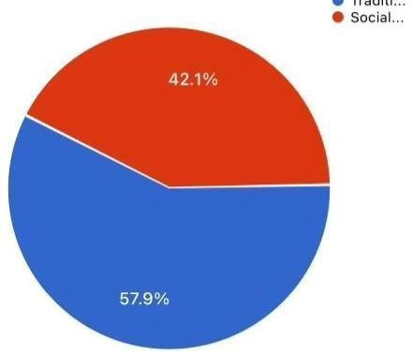

Fig. 1 Media Platform Usage

The findings reveal that social media is overwhelmingly the most frequently used platform, with nearly 90% of respondents preferring it over traditional sources. This indicates a strong shift toward digital consumption, while platforms like newspapers and podcasts have minimal reach. Insight: Despite the dominance of social media, its credibility remains questionable, creating a gap between usage and trust.

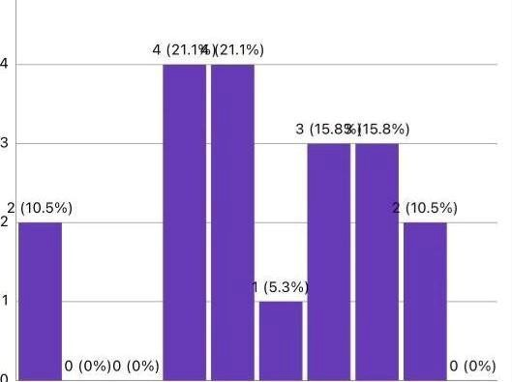

Fig. 2 Trust in Media

Responses show a moderate level of trust in media, with most ratings concentrated between 5 and 7 on a 10-point scale. This suggests that while media is still considered somewhat reliable, skepticism among users is clearly present. Insight: The audience is not blindly trusting media anymore—critical thinking is emerging, but not strongly enough to reject it entirely.

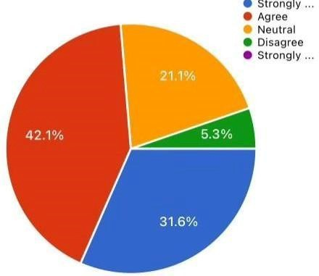

Fig. 3 Factors Influencing Trust

Source credibility and fact-checking emerge as the most significant factors influencing trust, followed closely by the quality of reporting. In contrast, peer recommendations and outlet reputation play a comparatively smaller role. Insight: Trust is becoming more evidence-based rather than brand-based, reflecting a shift toward informed media consumption.

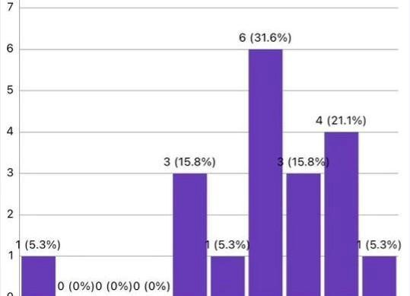

Fig. 4 Types of News Considered Important

Respondents consider social issues and science & technology as the most important types of news, followed by politics and entertainment. Health and economic news receive relatively less emphasis. Insight: Public interest is evolving toward progressive and innovation-driven topics, indicating a more future-oriented audience mindset.

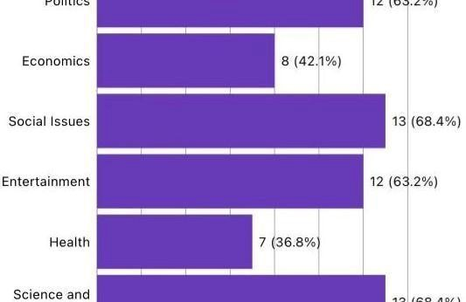

Fig. 5 Media Influence on Political Perception

Most respondents rated media influence between 6 and 9, highlighting a strong belief that media significantly shapes public opinion on political matters. Insight: Media continues to act as a powerful agenda-setter, reinforcing its role in shaping political narratives and public discourse.

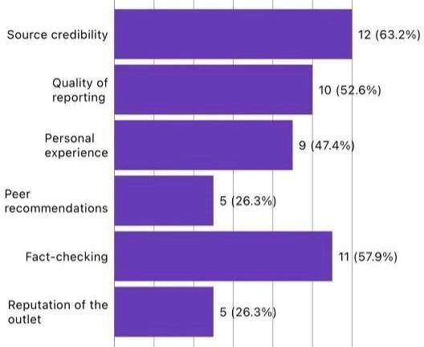

Fig. 6 Responsibility for Unbiased Information

A large majority agree or strongly agree that media has a responsibility to present unbiased information. Only a negligible portion disagrees. Insight: There is a clear expectation gap—people demand neutrality, even though they often consume biased platforms.

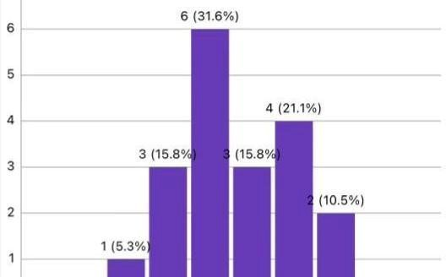

Fig. 7 Fact-Checking Behaviour

The data shows that respondents engage in fact-checking at a moderate level, with most responses between 4 and 8. This indicates awareness about misinformation but inconsistent verification practices. Insight: Awareness exists, but discipline doesn’t—people know they should verify, but don’t always follow through.

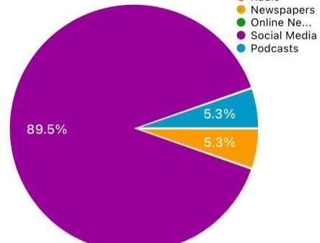

Fig. 8 Preferred Media Influence

More respondents believe that traditional media should have greater influence on public opinion compared to social media. Insight: Even in a digital-first era, traditional media is still perceived as more trustworthy, highlighting a credibility gap in modern platforms.

TABLE

Survey Aspect | Key Result | Insight
Media Platform Usage | ~89.5% prefer social media | Digital platforms dominate despite credibility concerns
Trust in Media | Mostly rated between 5–7/10 | M o d e r a t e t r u s t w i t h noticeable skepticism

Factors Influencing Trust | Credibility (63%), Fact-  checking (57.9%), Quality  reporting (52.6%) | Trust depends more on verification than reputation
Important News Types | Social Issues & Science/Tech (~68.4%) | Audience prefers progressive and future-oriented content
Media Influence on Politics | Majority rated 6–9/10 | Media strongly shapes political perception
Responsibility for Unbiased Information | ~73% agree/strongly agree | High expectation for ethical and unbiased journalism
Fact-Checking Behaviour | Mostly rated 4–8/10 | Aw a r e n e s s e x i s t s b u t consistency is lacking
Preferred Media Influence | ~57.9% favour traditional media | Traditional media still seen as more trustworthy

CONCLUSION
This review has examined the multifaceted role of media in shaping public opinion, revealing a complex landscape of media effects that defies simple causal narratives. The evidence substantiates that the media exerts substantial influence on public opinion formation through multiple mechanisms including agenda-setting, framing, risk amplification, and systematic provision of information that citizens use in opinion construction. Media determines what
people think about, how they think about it, and the factual foundations upon which opinion rests. Yet this influence operates within a system conditioned by individual differences, psychological processes, and social dynamics that moderate and sometimes constrain media
effects.

The transition from traditional to digital media has intensified media's opinion-shaping power while simultaneously creating new vulnerabilities to manipulation and misinformation. Algorithmic curation, fragmented media landscapes, and the capacity for coordinated disinformation campaigns present novel challenges for maintaining informed citizenry and

functional democratic deliberation. The democratization of content creation enabled by digital platforms offers potential for diverse perspective expression, yet algorithmic amplification of provocative content and filter bubble dynamics frequently reinforce polarization rather than promote understanding.
Addressing media's role in shaping public opinion requires multifaceted approaches spanning regulatory reform, institutional innovation, media literacy development, and platform design modifications. Media systems require strengthened democratic accountability mechanisms ensuring that commercial and political incentives do not override democratic functions. Media literacy education should expand across educational systems and adult populations, enhancing citizens' capacity to evaluate information critically and resist manipulation. Social media platforms must redesign algorithmic systems to reduce amplification of misinformation and polarizing content while maintaining user engagement. These interventions require recognition that media effects depend not merely on media content but on the interaction between content and audience characteristics, necessitating approaches tailored to specific populations and issue domains.
Looking forward, research priorities should include longitudinal studies examining media effects across extended time periods, investigation of digital media effects using experimental methods enabling causal inference, and examination of cross-national variation in media systems and effects. Understanding the media's role in opinion formation remains essential for researchers, practitioners, and citizens committed to maintaining democratic institutions capable of genuine self-governance by informed publics. As media systems continue evolving and technologies proliferate, sustained scholarly and practical attention to media's opinion-shaping mechanisms will remain indispensable for democratic societies.

REFERENCES
- Arceneaux, K., & Johnson, M. (2013). Changing minds or changing channels? Partisan news in an age of choice. University of Chicago Press.
- Ashley, S., Maksl, A., & Craft, S. (2015). Developing a news media literacy scale. Journalism & Mass Communication Educator, 68(2), 84-100.
- Cacioppo, J. T., & Petty, R. E. (1982). The need for cognition. Journal of Personality and Social Psychology, 42(1), 116-131.
- Chong, D., & Druckman, J. N. (2007). Framing theory. Annual Review of Political Science, 10, 103-126.

- Cinelli, M., Quattrociocchi, W., Galeazzi, A., et al. (2020). The COVID-19 social media infodemic. Nature Scientific Reports, 10, 16598.
- Croteau, D., & Hoynes, W. (2014). Media/society: Industries, images, and audiences (5th ed.). SAGE Publications.
- Druckman, J. N. (2001). On the limits of framing effects: Who can frame? Journal of Politics, 63(4), 1041-1066.
- Dunlap, R. E. (2016). Environmental sociology and the social shaping of environmentalism. In J. Michels (Ed.), Routledge handbook of political ecology (pp. 25-38). Routledge.
- Dunlap, R. E., & Brulle, R. J. (2015). Climate change and society. Oxford University Press.
- Entman, R. M. (1993). Framing: Toward clarification of a fractured paradigm. Journal of Communication, 43(4), 51-58.
- Evanega, S., Lynas, M., Adams, J., et al. (2020). Coronavirus misinformation: Quantifying sources and themes in the COVID-19 'infodemic'. Cornell Alliance for Science. https://allianceforscience.cornell.edu
- Freed, G. L., Clark, S. J., Butchart, A. T., & Singer, D. C. (2010). Parental vaccine safety concerns in 2009. Pediatrics, 125(4), 654-659.
- Gillespie, T. (2016). Algorithmically recognizable: Santorum's Google problem, and Google's Santorum problem. Information, Communication & Society, 20(1), 63-80.
- Gitlin, T. (1980). The whole world is watching: Mass media in the making and unmaking of the New Left. University of California Press.
- Hameleers, M. (2020). Needs-based media selection and use during election campaigns. Studies in Communication Sciences, 20(1), 41-53.
- Hobbs, R. (2010). Digital and media literacy: A plan of action. Aspen Institute Communications and Society Program.
- Jewkes, Y. (2015). Media and crime (3rd ed.). SAGE Publications.
- Kahan, D. M. (2017). The intellectually honest case against vouching, and for traditional public schools. Colorado Technology Law Journal, 15, 45-72.
- Kasperson, R. E., Renn, O., Slovic, P., et al. (1988). The social amplification of risk: A conceptual framework. Risk Analysis, 8(2), 177-187.

- Katz, E., Blumler, J. G., & Gurevitch, M. (1974). Utilization of mass communication by the individual. In J. G. Blumler & E. Katz (Eds.), The uses of mass communications (pp. 19-32). SAGE Publications.
- McChesney, R. W. (2013). Digital disconnect: How capitalism is turning the internet against democracy. The New Press.
- McCombs, M. E. (2004). Setting the agenda: The mass media and public opinion. Polity Press.
- McCombs, M. E., & Shaw, D. L. (1972). The agenda-setting function of mass media. Public Opinion Quarterly, 36(2), 176-187.
- Mueller, R. S. (2019). Report on the investigation into Russian interference in the 2016 presidential election. U.S. Department of Justice.
- Nyhan, B., & Reifler, J. (2010). When corrections fail: The persistence of political misperceptions. Political Behavior, 32(2), 303-330.
- Pariser, E. (2011). The filter bubble: What the internet is hiding from you. Penguin Press.
  - Pew Research Center. (2020). News consumption across social media in 2020. Pew Research Center.
- Scheufele, D. A. (2000). Agenda-setting, priming, and framing revisited: Another look at cognitive effects of political communication. Mass Communication & Society, 3(2-3), 297-316.
- Scheufele, D. A., & Tewksbury, D. (2007). Framing, agenda setting, and priming: The evolution of three media effects models. Journal of Communication, 57(1), 9-20.
- Stroud, N. J. (2010). Niche news and political polarization in the United States. Princeton University.
- Sunstein, C. R. (2001). Republic.com: Dealing with extreme democracy. Princeton University Press.
- Tversky, A., & Kahneman, D. (1981). The framing of decisions and the psychology of choice. Science, 211(4481), 453-458.
- van der Linden, S., & Lewandowsky, S. (2021). Countering misinformation and fake news through inoculation and prebunking. European Review of Social Psychology, 32(2), 348-384.

- van Dijck, J. (2013). The culture of connectivity: A critical history of social media. Oxford University Press.
- Wakefield, A. J., Murch, S. H., Anthony, A., et al. (1998). Ileal-lymphoid-nodular hyperplasia, non-specific colitis, and pervasive developmental disorder in children. The Lancet, 351(9103), 637-641.
- Wardle, C., & Ward, H. (2019). Misinformation is a serious global challenge. Poynter Institute.
- Woolley, S. C., & Howard, P. N. (2018). Computational propaganda worldwide. Oxford Internet Institute.
- Zaller, J. R. (1992). The nature and origins of mass opinion. Cambridge University Press.

